**Instructions**

* There are **2** questions in this assignment.
* Email/paper/other modes of submissions will not be accepted.
* Upload a word **version** of this document.
* Assignment submitted after due date will not be evaluated and a score of zero will be awarded.
* Plagiarism may lead to award of zero marks.

**Due Date: 12pm, 4th Sept. 2024**

**Submitting this Assignment**

You will submit (upload) this assignment in MS Teams. Name this document as GLA1_AJPODD2024_John_Doe.doc in case your name is John Doe, and this graded lab assignment is 1 of course whose acronym is AJP, and offered in ODD 2024. Paste your code after each question, paste the screenshot of output, save and upload the document.

**Grading Scheme:** This assignment has5 marks.

**Question 1:**

Create a web page for internal links; when the user clicks on different links on the web page it should go to the appropriate locations/sections in the same page.

**CODE:**

<!DOCTYPE html>

<html lang="en">

<head>

<meta charset="UTF-8">

<meta name="viewport" content="width=device-width, initial-scale=1.0">

<title>University Course Description</title>

<style>

body {

font-family: Arial, sans-serif;

line-height: 1.6;

padding: 0 20px;

}

nav {

background-color: #f4f4f4;

padding: 10px;

margin-bottom: 20px;

}

nav ul {

list-style: none;

padding: 0;

}

nav ul li {

display: inline;

margin-right: 10px;

}

nav ul li a {

text-decoration: none;

color: #333;

}

section {

margin-bottom: 40px;

}

h2 {

border-bottom: 2px solid #ccc;

padding-bottom: 10px;

margin-bottom: 20px;

}

</style>

</head>

<body>

<nav>

<ul>

<li><a href="#overview">Course Overview</a></li>

<li><a href="#syllabus">Syllabus</a></li>

<li><a href="#instructor">Instructor Information</a></li>

<li><a href="#contact">Contact Information</a></li>

</ul>

</nav>

<section id="overview">

<h2>Course Overview</h2>

<p>This course provides an introduction to the fundamentals of Information Technology, focusing on programming, web development, and software engineering principles. Students will learn how to design, develop, and maintain IT systems, along with gaining proficiency in key programming languages such as Java and Python.</p>

</section>

<section id="syllabus">

<h2>Syllabus</h2>

<p>The syllabus includes the following modules:</p>

<ul>

<li>Module 1: Introduction to Information Technology</li>

<li>Module 2: Front-end Web Development</li>

<li>Module 3: Java Programming</li>

<li>Module 4: Database Management Systems</li>

<li>Module 5: Software Engineering Principles</li>

<li>Module 6: Final Project and Evaluation</li>

</ul>

</section>

<section id="instructor">

<h2>Instructor Information</h2>

<p>Instructor: Dr. Jane Doe</p>

<p>Email: jane.doe@university.edu</p>

<p>Office Hours: Mondays and Wednesdays, 10:00 AM - 12:00 PM</p>

<p>Office Location: Room 123, Engineering Building</p>

</section>

<section id="contact">

<h2>Contact Information</h2>

<p>For any inquiries or assistance regarding the course, please reach out to:</p>

<p>Course Coordinator: John Smith</p>

<p>Email: john.smith@university.edu</p>

<p>Phone: (555) 123-4567</p>

<p>Office Location: Room 456, Information Technology Building</p>

</section>

</body>

</html>

**OUTPUT:**

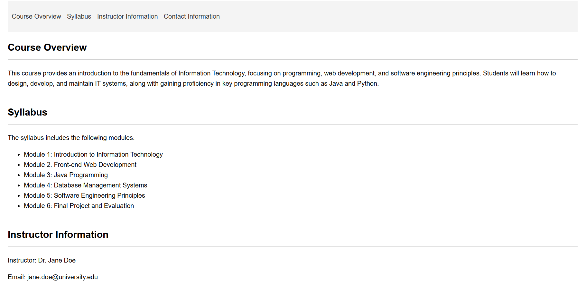

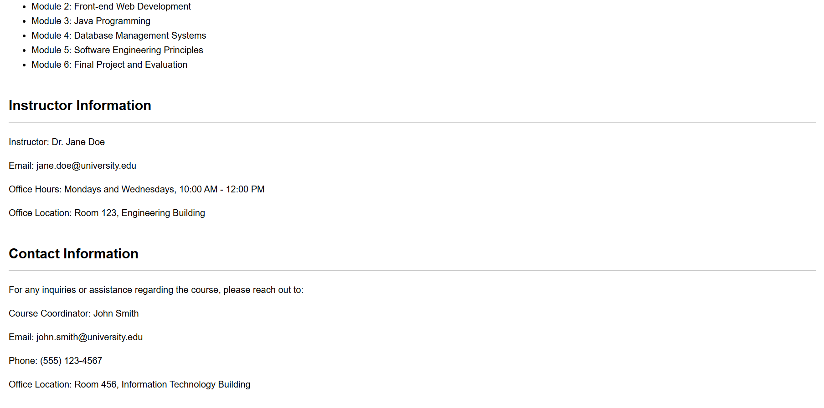

**Question 2:**

Create a web page, showing an ordered list of all semester courses enrolled.

**CODE:**

<!DOCTYPE html>

<html lang="en">

<head>

    <meta charset="UTF-8">

    <meta name="viewport" content="width=device-width, initial-scale=1.0">

    <title>Enrolled Semester Courses</title>

    <style>

        body {

            font-family: Arial, sans-serif;

            line-height: 1.6;

            padding: 20px;

            background-color: #f9f9f9;

        }

        h1 {

            color: #333;

            text-align: center;

            margin-bottom: 20px;

        }

        ol {

            background: #fff;

            padding: 20px;

            border-radius: 5px;

            box-shadow: 0 0 10px rgba(0, 0, 0, 0.1);

        }

        ol li {

            margin-bottom: 10px;

            padding: 10px;

            border-bottom: 1px solid #ddd;

        }

        ol li:last-child {

            border-bottom: none;

        }

    </style>

</head>

<body>

    <h1>Semester Courses Enrolled</h1>

    <ol>

        <li>CSF416: Web Technology and Application</li>

        <li>CSF374: DevOps</li>

        <li>CSF444: Internet Of Things</li>

        <li>CEF349: Remote Sensing and Image Processing</li>

        <li>LAF284: Principle Of Management</li>

    </ol>

</body>

</html>

**OUTPUT:**

